Cotiviti Practicum – Fall 2026
MS in Biomedical Informatics w/ emphasis in Data Science and AI.
Tara Allred

Timeline: August 24th- December 11th 2026
Practicum Requirements: 180-200 hours
Cotiviti Team Meetings: Thursday’s at 130pm MST.

U of U Breaks : No meetings
· Fall Break: October 10-18th
· Thanksgiving: November 26-29th
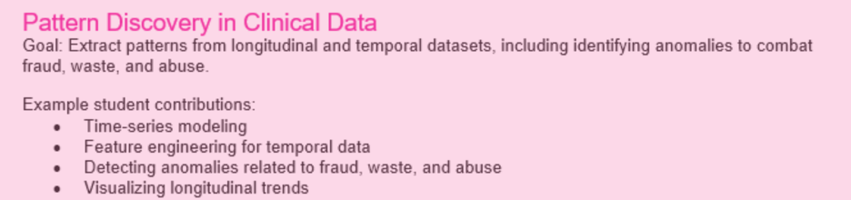

Initial Dataset
CMS Medicare Post-Acute Care Utilization – Inpatient Rehabilitation Facility by Geography and Provider

Project Approach:
Data Problem Research Question Hypothesis Analysis Evidence Conclusion

Phase 1: August 24th – September 11th
· Dataset exploration + Research Question Development
· Cotiviti Feedback
o What findings are meaningful from an industry perspective?
o What questions are worth pursuing?
o What am I not seeing?
o What additional AI tools would be helpful?

Phase 2: Sep 14th-October 9th
· Data Preparation and Data Analysis
o Clean data
o Add additional datasets where needed
o Develop initial visualizations.
· Cotiviti Feedback
o Do findings support the research question?
o Should the Hypothsis be refined?
o Is anything missing?
o How would Cotiviti tackle this in a way that I am not seeing?
· Milestone: analysis ready dataset, and research question finalized.

FALL BREAK: OCT-10th-18th – NO CLASS OR MEETINGS

Phase 3: Oct 19th – Nov 6th
· Testing the research question
o Engineer features
o Apply appropriate statistical data and/or methods.
o Test the hypothesis
o Evaluate significance and investigate further
· Cotiviti Feedback
o Are the results being interpreted correctly?
o Are these findings meaningful to Cotiviti? How would you proceed?
o What additional analysis would help here?

Phase 4: Nov 9th – Nov 25th
· Results and Validation
o Refine and validate the results
o Find similar research
o Investigate alternative explanations
o Biases?
o Develop and fine tune Visualizations
o Does the evidence support the hypothesis?
· Cotiviti Feedback
o What conclusions are supported?
o What additional tools or methods can be used to reach a conclusion?
o What are the limitations? Can you work around them?
o How could findings translate into a similar project with Cotiviti?

THANKSGIVING BREAK Nov 26th-29th NO CLASS OR MEETINGS

Nov 30th -Dec 11th
· Final Paper and Analysis + Capstone Direction
o EDIT!
o Summarize question, methods, results and conclusions.
o Create PP presentation.
o Incorporate Cotiviti Feedback
· Cotiviti Feedback
o Is the project story clear?
o Are conclusions supported by evidence?
o Take away? Good/Bad
o What could have been done differently and what worked well?

